Final Report
By Cody Kou

Abstract:
'Comments' and 'Host Type Platform' are the 2 indicators more important. For instance, after 600 comments or 4 comments per minute, the performance of the host, in terms of Total GMV, will obviously improve.

Processing and findings:
After handling the missing values and considering the business content, only those meaningful/useful numerical features (total number if available for those divided by EN/CN) are kept for analyses. And the Total GMV ($) is defined as the target variable for success of performance.
Data distribution bar charts are plotted and shown as below:
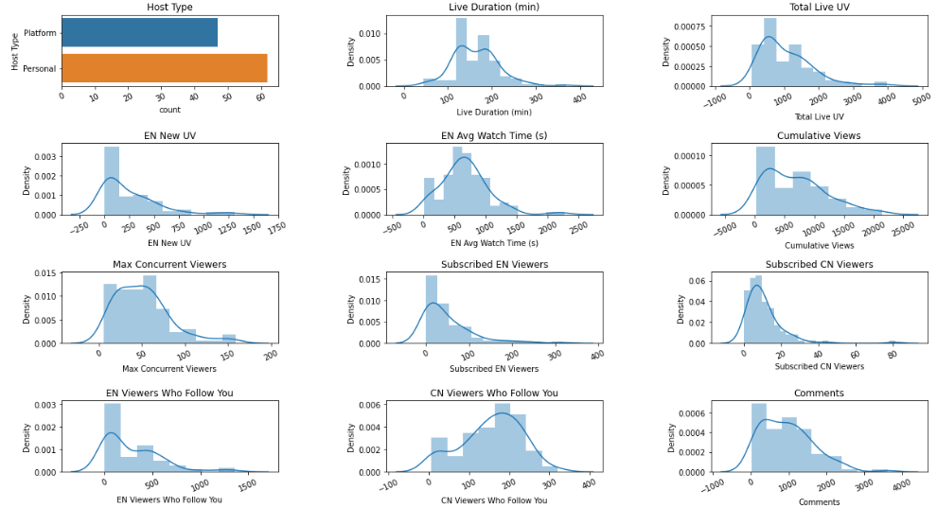

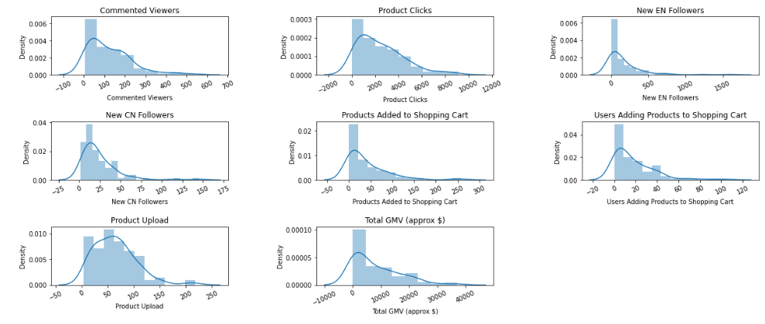

Also, feature correlation heat map is plotted and shown as below:
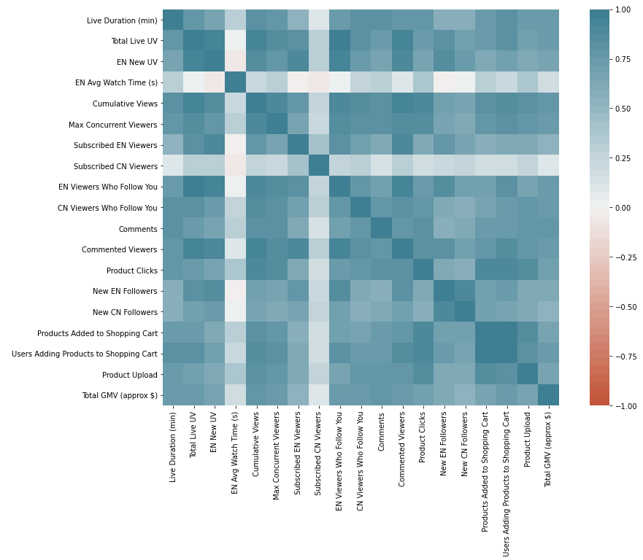

Linear Regression Model:
Categorical features are converted to numerical, linear regression is performed with constant added. The summary result shown as below:
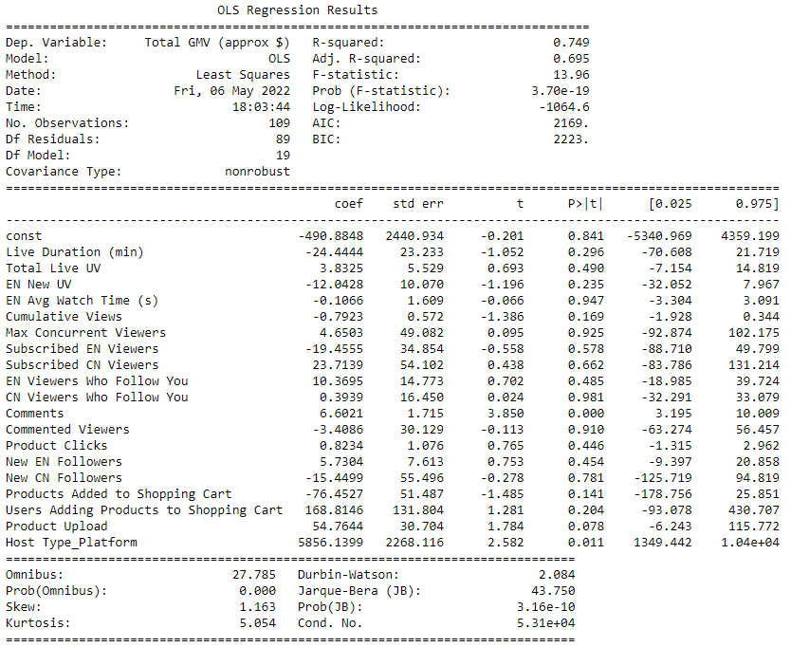

Based on the summary result, 'Comments' and 'Host Type Platform' are the 2 features with significant coefficient p-value (<0.05). In another word, the number of comments and whether the host is broadcasting on platform are the more important indicators for success.

Then, plots for “number of comments vs. total GMV” and “number of comments per minute vs. total GMV are drawn and shown as below:

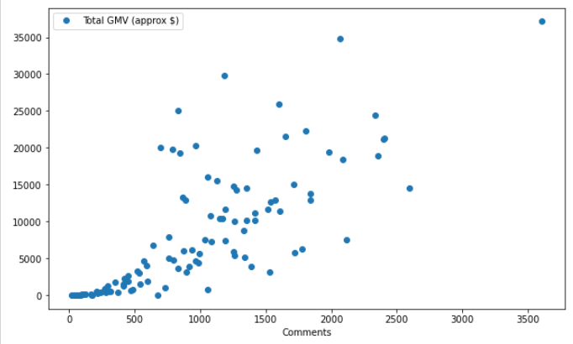
After approximate 600 comments, the total GMV started to spread out with an overall significant uptrend.
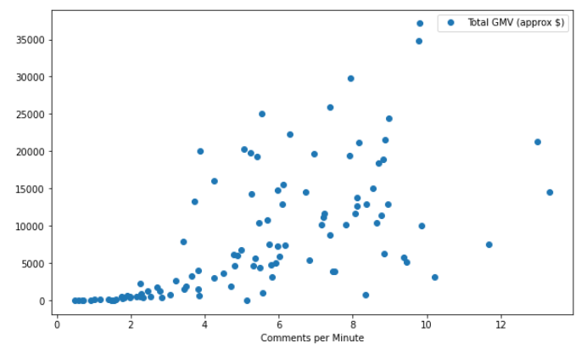
After 4 comments per minute, the total GMV started to spread out with an overall significant uptrend.

Summary:
- 'Comments' and 'Host Type Platform' are the 2 indicators more important.
- After 600 comments or 4 comments per minute, the performance of the host, in terms of Total GMV, will obviously improve.

Future Consideration:
- Different target variable for success could be used for analysis, such as orders, product sold, etc.
- Start time could be useful provided more record.
- The live title could be very useful indicator with NLP skill applied.
- The analysis may be limited to the specific host provided.

